<LOGO>

Last Update Date | <DATE>
Owner | <OWNER>
Status | <STATUS>

Procedure for control of documented information

Approval History

Version | Approved By | Approved On
1.0 | <APPROVER> | <DATE>

1. Introduction
As a governance best practice at <Company> all documents that make up the Information Security Management System (ISMS) are controlled. Even <applicable practices> i.e. ISO 27001 standard requires that all documented information be controlled.
This document describes the controls in place for
<PRACTICES> I.E.
- The naming and versioning of documents and associated attributes.
- Availability of the documents
- Review and approval of the documents
- Withdrawing documents when they are obsolete and
- Retention of documents required for legal or knowledge preservation purposes

2. Procedure overview

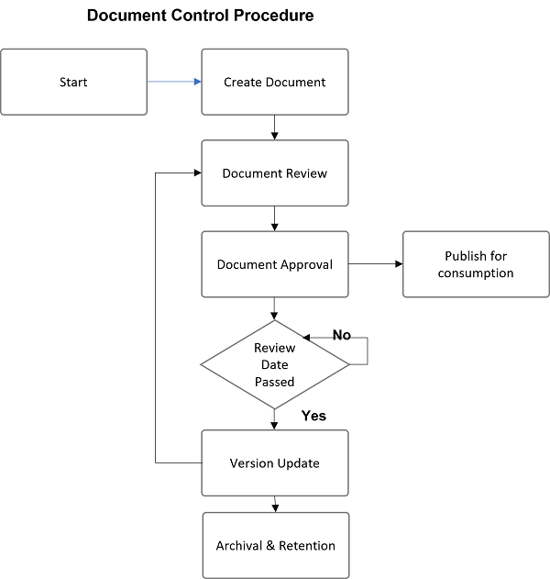

3. Create Documents
The document's creation is generally driven by the System Context and the requirements of the business based on its external and internal issues. Most of the documents are driven by what the management needs in terms of Policies, Procedures, Governance Documents, etc.

3.1 Naming Convention
The naming convention is automatic if you are using CyberFort Platform <PLATFORM EXAMPLE>.
Naming convention should be entirely driven by your company's need for legibility and readability. If you are creating general documentation, keep the naming convention that addresses your organization's needs.
Example of naming conventions
XXX-YY-TITLE-VERSION-DATE
XXX - POL, PRO, GOV
YY - ID (01, 02 etc)

3.2 Version Control
ControlMap automatically applies minor and major versions whenever a policy is approved, and a new version is created for review.
[ If you are managing policies outside of CyberFort Platform, please describe your versioning method ]

3.3 Document Status
In ControlMap, the document status could be one of
- Draft (Work has not started)
- In Progress (Work is in progress)
- In Review (Contributors and the team is reviewing the document)
- Ready for approval (The document is ready for approval and is with Approver)
- Approved (The document is currently approved)
[ If you are managing policies outside of CyberFort Platform, please describe your statuses here]

4. Document Review
Document review is performed by the owner of the document or the contributors who are assigned to review or contribute to the document.
All contributors are tracked.

5. Document Approval
An assigned approver approves the documents assigned. The approvers are different for each document and depend on the document domain and its contents.

6. Publish & Communicate
All relevant changes to documents are communicated to the relevant stakeholders.
All changes, updates, and modifications are communicated to the policy owners, team members, approvers, and contributors. In CyberFort Platform, a distribution list for a document can be created by adding individuals as Watchers on a document.

7. Retention and Archiving
Approved documents exceeding their useful life are stored in an archival folder on Google Drive or a similar shared drive. Paper copies can be kept in secure bins or shredded if no longer needed.

